A
PROJECT REPORT
ON

BigBasket Product & Pricing Analytics:

An Advanced EDA Approach Using Real-World

E-commerce Data

OF

BACHELOR OF TECHNOLOGY
Computer Science & Engineering
(Artificial Intelligence and Machine Learning)

SUBMITTED BY

Suraj Rameshwar Bhandare
ISTU No.: 24010050006


DEPARTMENT OF COMPUTER SCIENCE & ENGINEERING
(Artificial Intelligence and Machine Learning)

G H RAISONI INTERNATIONAL SKILL TECH UNIVERSITY, PUNE

2025-26



CERTIFICATE

This is to certify that the project report entitled

BigBasket Product & Pricing Analytics: An Advanced EDA Approach Using Real-World E-commerce Data

Submitted by

SURAJ RAMESHWAR BHANDARE - Roll No: SA260

is a bonafide students of this institute and the work has been carried out by them under the supervision of Prof. Sachin Shinde and it is approved for the partial fulfillment of the requirement of the G H Raisoni International Skill Tech University, Pune, for the award of the degree of Bachelor of Technology in …………………………………..…… in the academic year 2025-26.

Prof. Sachin D Shinde (Dr. S S Balwante)
Guide H.O.D.

(……………………….) (Dr. Rahat Khan)
External Examiner I/C Dean
GHRISTU, Pune

Date:
Place: Pune

ACKNOWLEDGMENT

It gives us great pleasure in presenting “BigBasket Product & Pricing Analytics: An Advanced EDA Approach Using Real-World E-commerce Data” as my B.Tech. project. Words have never seemed as inadequate as now when I am endeavoring to express our gratitude at the culmination of our B. Tech. Project to all those who have made it possible. Even the best efforts are waste, without the proper guidance and advice of our project guide Prof. Sachin D Shinde for the consistent guidance, co-operation, inspiration, practical approach and constructive criticism, which provided us the much-needed impetus to work hard & also thanks Dr. S S Balwante Head of Computer Engineering Department for their continuous support & valuable suggestions.
We take this opportunity to thank Dr. Rahat Khan, I/C Dean SOET for her whole hearted support, motivation & valuable suggestions.
We would also like to thank Prof. Sachin Shinde our Project Coordinators for their valuable support in providing us with the required information.
At the end, we would like to give special thanks to all staff members from Computer Engineering Department of G H Raisoni International Skill Tech University, Pune & our colleagues for their kind support & timely suggestions.

SURAJ RAMESHWAR BHANDARE
SA260

ABSTRACT

The rapid growth of India’s online grocery ecosystem has increased the demand for robust data analytics to understand product pricing, customer buying patterns, and category-wise market dynamics. BigBasket—one of India’s largest online grocery platforms—provides a diverse and comprehensive dataset that is ideal for real-world Exploratory Data Analysis (EDA). This project performs an extensive EDA on the BigBasket product dataset to extract meaningful insights related to pricing behaviour, brand distribution, discount patterns, product categories, and customer ratings.
The study follows a systematic data preprocessing approach involving the treatment of missing values, management of outliers, and ensuring overall data consistency. Using powerful Python libraries such as Pandas, NumPy, Matplotlib, Seaborn, and Plotly, a variety of visual analytics were conducted to evaluate the performance of product categories, identify top-selling or frequently listed brands, analyze discount strategies, and study pricing variations across segments.
The insights derived from this analysis reveal key trends such as high-value categories, popular brands, rating distributions, and category-specific discount behaviour. These findings can assist businesses in optimizing inventory planning, improving product placement, strengthening marketing strategies, and making data-driven pricing decisions. Overall, this project highlights the practical importance of EDA in understanding large-scale e-commerce datasets and offers a strong foundation for further predictive and analytical modeling.
Keywords: BigBasket, Exploratory Data Analysis (EDA), Data Cleaning, Data Visualization, Pricing Analytics, Product Categorization, Python.

iv

TABLE OF CONTENTS

 |  |  |  |  | Page No.
CERTIFICATE |  |  |  |  | ii
ACKNOWLEDGMENT |  |  |  |  | iii
ABSTRACT |  |  |  |  | iv
TABLE OF CONTENT  LIST OF FIGURES |  |  |  |  | v viii
LIST OF TABLES |  |  |  |  | ix
LIST OF ABBREVIATIONS |  |  |  |  | x
Sr. No. |  | Title of Chapter |  |  | Page No.
01 |  | Introduction |  |  | 01
 | 1.1 | Overview |  |  | 01
 | 1.2 | Motivation |  |  | 01
 | 1.3 | Problem Definition and Objectives |  |  | 02
 | 1.4 | Project Scope & Limitations |  |  | 03
 | 1.5 | Methodologies of Problem solving |  |  | 02
02 |  | Literature Survey |  |  | 03
03 |  | Software Requirements Specification |  |  | 04
 | 3.1 | Assumptions and Dependencies |  |  | 04
 | 3.2 | Functional Requirements |  |  | 04
 |  | 3.2.1 |  | System Feature 1(Functional Requirement) | 04
 |  | 3.2.2 |  | System Feature2 (Functional Requirement) | 05
 | 3.3 | External Interface Requirements (If Any) |  |  | 05
 |  | 3.3.1 |  | User Interfaces | 05
 |  | 3.3.2 |  | Hardware Interfaces | 05
 |  | 3.3.3 |  | Software Interfaces | 05
 |  | 3.3.4 |  | Communication Interfaces | 05
 | 3.4 | Nonfunctional Requirements |  |  | 05
 |  | 3.4.1 |  | Performance Requirements | 05
 |  | 3.4.2 |  | Safety Requirements | 06
 |  | 3.4.3 |  | Security Requirements | 06
 |  | 3.4.4 |  | Software Quality Attributes | 06
 | 3.5 | System Requirements |  |  | 06
 |  | 3.5.1 |  | Database Requirements | 06
 |  | 3.5.2 |  | Software Requirements (Platform Choice) | 06
 |  | 3.5.3 |  | Hardware Requirements | 06
 | 3.6 | Analysis Models: SDLC Model to be applied |  |  | 06
04 |  | System Design |  |  | 07
 | 4.1 | System Architecture |  |  | 08
 | 4.2 | Mathematical Model |  |  | 08
 | 4.3 | Data Flow Diagrams |  |  | 08
 | 4.4 | Entity Relationship Diagrams |  |  | 09
 | 4.5 | UML Diagrams  vi |  |  | 09
05 |  | Project Plan |  |  | 11
 | 5.1 | Project Estimate |  |  | 11
 |  | 5.1.1 | Reconciled Estimates |  | 11
 |  | 5.1.2 | Project Resources |  | 11
 | 5.2 | Risk Management |  |  | 11
 |  | 5.2.1 | Risk Identification |  | 12
 |  | 5.2.2 | Risk Analysis |  | 12
 |  | 5.2.3 | Overview of Risk Mitigation, Monitoring, Management |  | 12
 | 5.3 | Project Schedule |  |  | 12
 |  | 5.3.1 | Project Task Set |  | 12
06 |  | Project Implementation |  |  | 13
 | 6.1 | Overview of Project Modules |  |  | 13
 | 6.2 | Tools and Technologies Used |  |  | 13
 | 6.3 | Algorithm Details |  |  | 14
 |  | 6.3.1 | Algorithm 1 |  | 14
 | 6.4 | 6.3.2  Project | Algorithm 2  Implementation |  | 14  14
07 |  | Results |  |  | 17
 | 7.1 | Outcomes |  |  | 17
 | 7.2 | Screen Shots |  |  | 17
08 |  | Conclusions |  |  | 26
 | 8.1 | Conclusions |  |  | 26
 | 8.2 | Future Work |  |  | 26
 | 8.3 | Applications |  |  | 27
References |  |  |  |  | 28

vii

LIST OF FIGURES

Figure No. | Title / Illustration | Page No.
4.1 | System Architecture Diagram | 7
4.3.1 | Data Flow Diagram (DFD) – Level 0 | 8
4.3.2 | Data Flow Diagram (DFD) – Level 1 | 8
4.4 | Entity Relationship (ER) Diagram | 9
4.5.1 | UML Use Case Diagram | 9
4.5.2 | UML Activity Diagram | 9
4.5.3 | UML Class Diagram | 10
7.1 | Mounting Google Drive using drive.mount() | 17
7.2 | Importing Python Libraries | 17
7.3 | Dataset Head – df.head(12) | 17
7.4 | Statistical Summary – df.describe() | 18
7.5 | Dataset Structure – df.info() | 18
7.6 | Creating Discount Column Code | 19
7.7 | Missing Values Before Cleaning | 19
7.8 | Discount Column Preview | 20
7.9 | Rating Boxplot – Outlier Detection | 20
7.10 | Data Cleaning Code Screenshot | 21
7.11 | Missing Values After Cleaning | 21
7.12 | Top 5 Frequent Products Count | 22
7.13 | Bottom 5 Products Count | 22
7.14 | Top 5 Product Bar Chart | 22
7.15 | Top 7 Sub-categories by Market Price | 23
7.16 | Top 7 Sub-categories by Sale Price | 23
7.17 | Total Market Price by Category | 24
7.18 | Top 7 Brands by Market Price | 24
7.19 | Category-wise Product Count | 25
7.20 | Average Discount by Category | 25

Viii

LIST OF TABLES

Table No. | Title / Description | Page No.
5.1 | Project Estimate – Time Allocation for Each Phase | 11
5.1.1 | Reconciled Estimates – Initial vs. Final Modified Timelines | 11
5.2.1 | Risk Identification Table | 12
5.2.2 | Risk Analysis (Impact–Probability Table) | 12
5.2.3 | Risk Mitigation, Monitoring & Management | 12
5.3 | Project Schedule – Weekly Timeline | 12
5.3.1 | Project Task Set – Task Breakdown | 12

ix

LIST OF ABBREVIATIONS

ABBREVIATION | ILLUSTRATION
AI | Artificial Intelligence
CSV | Comma Separated Values
CPU | Central Processing Unit
DALC | Data Analysis Life Cycle
df | DataFrame
EDA | Exploratory Data Analysis
GB | Gigabyte
IDE | Integrated Development Environment
IQR | Interquartile Range
ML | Machine Learning
MP | Market Price
MRP | Maximum Retail Price
np | NumPy
OS | Operating System
PC | Personal Computer
pd | Pandas
PII | Personally Identifiable Information
plt | Matplotlib PyPlot
px | Plotly Express
Q1 | First Quartile
Q3 | Third Quartile
RAM | Random Access Memory
R1–R5 | Risk Codes
SDLC | Software Development Life Cycle
sns | Seaborn
SP | Sale Price
SSD | Solid State Drive

x

1. Introduction

1.1 Overview
The Indian e-commerce industry has grown rapidly over the past decade, especially in the online grocery segment. BigBasket, India’s leading online grocery platform, provides thousands of products across various categories such as vegetables, dairy, beverages, household essentials, and personal care. Understanding the structure and behaviour of such a large real-world dataset requires the use of data analytics and visualization techniques.
This project uses the BigBasket dataset to perform a comprehensive Exploratory Data Analysis (EDA). The analysis focuses on identifying product trends, pricing behaviour, category distribution, brand performance, and customer rating patterns using real-world data.

1.2 Motivation
The motivation behind this project is driven by:
- The growing importance of data-driven decisions in e-commerce.
- The need to analyze real-world datasets rather than simulated data.
- Understanding how product pricing, discounts, and ratings influence customer behaviour.
- Learning essential concepts of data cleaning, preprocessing, visualization, and business insights.
- Gaining practical experience using Python for analytics tasks (Pandas, NumPy, Matplotlib, Seaborn, Plotly).
BigBasket’s dataset provides a perfect opportunity to study real e-commerce patterns and extract meaningful insights.

1.3 Problem Definition and Objectives

Problem Definition
“To analyze BigBasket’s real-world product dataset using Exploratory Data Analysis (EDA) to understand pricing patterns, category-wise trends, brand distribution, discount behaviour, and customer rating insights.”

Objectives
- To understand the structure and components of the BigBasket dataset.
- To clean the dataset by handling missing data and outliers.
- To perform statistical analysis on pricing, brands, ratings, and categories.
- To visualize product trends using advanced graphs.
- To identify top-selling categories, highly discounted brands, and product pricing behaviour.
- To generate business insights for e-commerce decision-making.

1.4 Project Scope & Limitations

Scope
- Focuses on BigBasket’s product-level dataset.
- Covers pricing analysis, category distribution, brand analysis, discount evaluation, and rating insights.
- Uses Python libraries for data preprocessing and visualization.
- Generates insights useful for inventory planning, product strategy, and marketing.

Limitations
- Dataset contains some missing values and inconsistent entries.
- Customer behaviour cannot be directly predicted due to lack of user-level data.
- Dataset represents products only, not transactions or real-time sales.

1.5 Methodologies of Problem Solving
The project follows a systematic data analytics methodology:
- Dataset Collection
BigBasket product dataset (real-world data).
- Data Preprocessing
  - Handle missing values
  - Detect and treat outliers
  - Convert data types
  - Remove inconsistencies
- Exploratory Data Analysis
  - Univariate and multivariate visualizations
  - Category-wise, price-wise, and brand-wise analytics
- Data Visualization
  - Matplotlib
  - Seaborn
  - Plotly for interactive charts
- Insights & Interpretation
  - Business trends
  - Category performance
  - Pricing strategy insights
- Conclusion & Recommendations
Summarizing findings for e-commerce use cases.

2. Literature Survey
The online grocery and e-commerce industry in India has experienced tremendous growth over the last decade, driven by increasing internet penetration, digital payments, and rapid urbanization. Several studies have explored the role of data analytics in understanding product performance, pricing trends, and customer behaviour in e-commerce platforms.
A study by K. Sharma et al. (2021) emphasized the importance of Exploratory Data Analysis (EDA) in identifying price variations, brand dominance, and classification of product categories within large e-commerce datasets. Their research highlighted how data preprocessing and visualization techniques can significantly improve the quality of insights derived from raw datasets.

Another study by B. Singh and Verma (2022) analyzed grocery e-commerce data to understand customer preferences and pricing trends. They concluded that discounts, product ratings, and brand trust play crucial roles in influencing online purchase decisions. Their work demonstrated the relevance of analyzing sale price versus market price variations to identify consumer purchasing behaviour.
Research by T. Rao (2023) on e-commerce product datasets showed that category-wise segmentation and brand-wise price distribution help companies optimize inventory management and marketing strategies. This study also emphasized the value of identifying outliers and missing data, as they can distort the validity of analysis in real-world datasets.In recent studies, such as the one conducted by D. Patel (2023), visualization tools like Matplotlib, Seaborn, and Plotly were used to uncover hidden patterns in large online retail datasets. Their findings revealed that interactive visualizations help stakeholders better understand pricing behaviour and category trends.
The BigBasket dataset has also been referenced in multiple open-source data analytics projects for educational and research purposes. These projects commonly focus on analyzing pricing distribution, brand diversity, category segmentation, and rating patterns.
From the literature reviewed, it is evident that:
- Real-world e-commerce datasets require extensive data cleaning.
- Pricing and category analysis play a key role in business decision-making.
- Visual analysis helps identify trends that are not easily visible in raw data.
- EDA is a powerful approach for summarizing and interpreting complex datasets.

Thus, this project builds on existing research by applying advanced EDA techniques to BigBasket’s real-world dataset, generating insights that can support strategic planning in online grocery platforms.

3. Software Requirements Specification (SRS)

The Software Requirements Specification (SRS) defines the complete requirements of the project
“BigBasket Product & Pricing Analytics: An Advanced EDA Approach Using Real-World E-commerce Data”.
It outlines assumptions, functional requirements, non-functional requirements, system interfaces,
and resources needed to carry out the exploratory data analysis process effectively.

3.1 Assumptions and Dependencies
• The dataset used for analysis is accurate and sourced from real BigBasket product data.
• The dataset format is consistent (CSV) and contains attributes such as product name, category,
brand, sale price, market price, rating, etc.
• Python environment (Jupyter/Colab) is available for running the analysis.
• Internet connection may be required for certain Python libraries installation.
• System has sufficient memory to load and process the dataset of approximately 27,500+ rows.
• User has basic understanding of Python and data analysis concepts.
• Visualization libraries (Matplotlib, Seaborn, Plotly) are compatible with the system.

Dependencies:
• Python version 3.8+
• Pandas, NumPy, Matplotlib, Seaborn, and Plotly libraries
• Google Colab or Jupyter Notebook platform

3.2 Functional Requirements

3.2.1 System Feature 1 — Data Preprocessing
• Load the BigBasket dataset from CSV format.
• Identify and handle missing values (mean/mode imputation).
• Detect and treat outliers in price-related columns.
• Convert data types where necessary.
• Clean the dataset to ensure accuracy and consistency.

3.2.2 System Feature 2 — Exploratory Data Analysis
• Perform descriptive statistical analysis on dataset columns.
• Generate visualizations such as:
- Category distribution
- Pricing distribution
- Brand-wise average price
- Top selling products
- Discount comparison
• Generate interactive visualizations using Plotly (optional).
• Provide business insights based on analysis.

3.3 External Interface Requirements (If Any)

3.3.1 User Interface
• Python Notebook environment (Google Colab/Jupyter).
• Charts and visual outputs for user interpretation.
• Simple code cells to run EDA steps sequentially.

3.3.2 Hardware Interfaces
• Laptop/PC for running the analysis.
• Minimum 4GB RAM required (8GB recommended).
• CPU that supports multi-thread computation.

3.3.3 Software Interfaces
• Operating System: Windows / Linux / MacOS
• Python 3.8+ runtime environment
• Required Libraries:
- pandas
- numpy
- matplotlib
- seaborn
- plotly

3.3.4 Communication Interfaces
• Internet connection required for:
- Library installation
- Using Google Colab
- Dataset import from Google Drive

3.4 Non-Functional Requirements

3.4.1 Performance Requirements
• The analysis should complete within a reasonable time (1–3 minutes depending on hardware).
• Visualizations should load without lag in the notebook environment.
• Memory usage should be optimized by removing unnecessary columns or using efficient data types.

3.4.2 Safety Requirements
• Dataset should not contain personally identifiable information (PII).
• File handling must ensure that original dataset is not corrupted.

3.4.3 Security Requirements
• Dataset should be stored in a secure local folder or cloud drive.
• Unauthorized modification to the dataset should be prevented.
• Notebook should not execute untrusted or harmful code.

3.4.4 Software Quality Attributes
• Reliability: High — analysis depends on stable Python libraries.
• Usability: Easy to run using Colab/Jupyter.
• Maintainability: Code is modular, readable, and well-structured.
• Portability: Can run on multiple platforms.
• Efficiency: Optimized data preprocessing and visualization.

3.5 System Requirements

3.5.1 Database Requirements
• No relational database required.
• Dataset stored in CSV format.
• Efficient reading using pandas.read_csv().

3.5.2 Software Requirements
• Python 3.8 or above
• Jupyter Notebook / Google Colab
• IDE (Optional):
- VS Code
- PyCharm

3.5.3 Hardware Requirements
Minimum:
• 4GB RAM
• Dual-core Processor
• 500MB free storage space

Recommended:
• 8GB RAM
• SSD storage
• Quad-core Processor

3.6 Analysis Models: SDLC Model to be Applied

The project follows the Data Analysis Life Cycle (DALC), which includes:

1. Data Collection
2. Data Cleaning & Preparation
3. Exploratory Data Analysis (EDA)
4. Visualization & Interpretation
5. Insight Generation
6. Report Preparation

This SDLC model is most suitable as the project focuses on real-world dataset analysis rather
than software development.

4. System Design
System design provides a conceptual and structural representation of how data flows, is processed, and analyzed in the BigBasket EDA project. This chapter includes system architecture, mathematical model, data flow diagrams, ER diagrams, and UML diagrams relevant to the analytical workflow.

4.1 System Architecture

The system architecture for the BigBasket EDA project consists of the following components:

1. Data Source Layer:
• BigBasket real-world product dataset (CSV format)

2. Data Ingestion Layer:
• Loading dataset using pandas.read_csv()
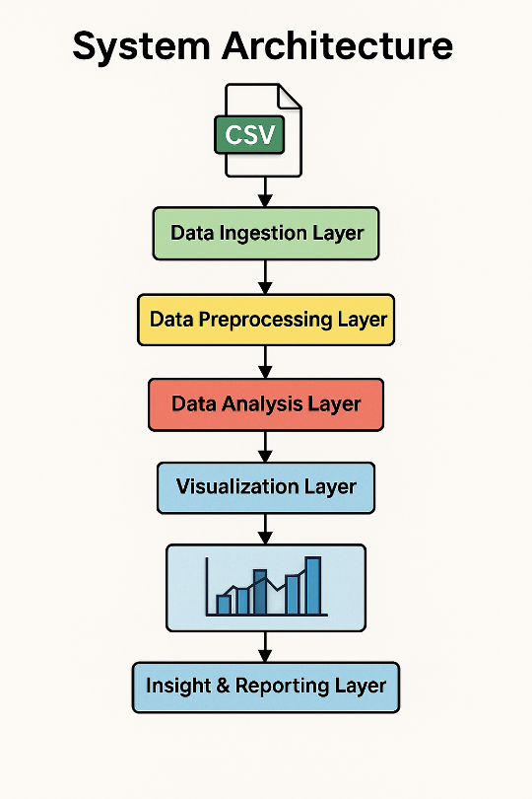
• Google Drive / Local storage access

3. Data Preprocessing Layer:
• Missing value handling
• Outlier detection and correction
• Data type conversion
• Cleaning inconsistent data

4. Data Analysis Layer:
• Statistical analysis using Pandas & NumPy
• Grouping, aggregation, and correlation analysis
• Feature extraction (discount, category summaries, etc.)

5. Visualization Layer:
• Matplotlib for static plots
• Seaborn for statistical plots
• Plotly for interactive visualizations

6. Insight & Reporting Layer:
• Business insights from graphs
• Documentation and findings
• Final project report creation

4.2 Mathematical Model
Let D = {d1, d2, d3, ..., dn} represent the BigBasket dataset containing n tuples (rows).

Each tuple di consists of attributes:
di = {product, category, sub_category, brand, sale_price, market_price, rating, description}

Where:
• sale_price ∈ ℝ+
• market_price ∈ ℝ+

• category ∈ C (set of categories)
• brand ∈ B (set of brands)

The discount function is defined as:
Discount(d) = market_price(d) – sale_price(d)

Average price function:
AvgPrice(Ci) = ( Σ sale_price(d) for all d in category Ci ) / count(Ci)

Outlier detection using IQR:
IQR = Q3 – Q1
Upper bound = Q3 + 1.5 × IQR
Lower bound = Q1 – 1.5 × IQR

If sale_price(d) > Upper bound:
sale_price(d) = mean(sale_price)

Goal:
Extract insights I = f(D)

Where f represents:
• statistical operations
• grouping functions
• visualization mapping

4.3 Data Flow Diagrams (DFD)

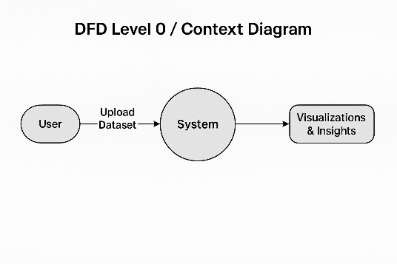
4.3.1 DFD Level 0 — Context Diagram
• User uploads dataset (CSV)
• System loads data into the analysis environment
• Preprocessing is applied
• Visualizations & insights are generated
• User receives final visual outputs and conclusions

4.3.2 DFD Level 1 — Detailed Data Flow
1. Input Data:
User loads dataset → System reads CSV → Raw Data Frame created
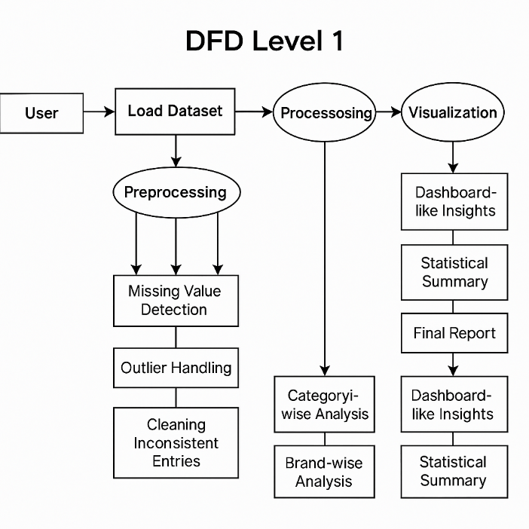
2. Preprocessing:
→ Missing value detection
→ Outlier handling
→ Cleaning inconsistent entries

3. Analysis:
→ Category-wise analysis
→ Brand-wise analysis
→ Price and discount computation
→ Rating patterns

4. Visualization:
→ Bar charts
→ Line graphs
→ Pie charts
→ Interactive plots (optional)

5. Output:
→ Dashboard-like insights
→ Statistical summary
→ Final report

4.4 Entity-Relationship (ER) Diagram

Entities:

1. Product
- product_id
- product_name
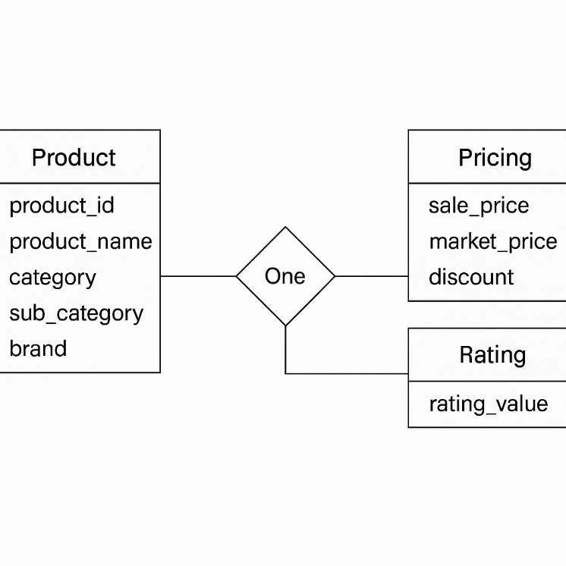
- category
- sub_category
- brand
2. Pricing
- sale_price
- market_price
- discount

3. Rating
- rating_value

Relationships:
• One Product → One Pricing
• One Product → One Rating
• One Category → Many Products

4.5 UML Diagrams

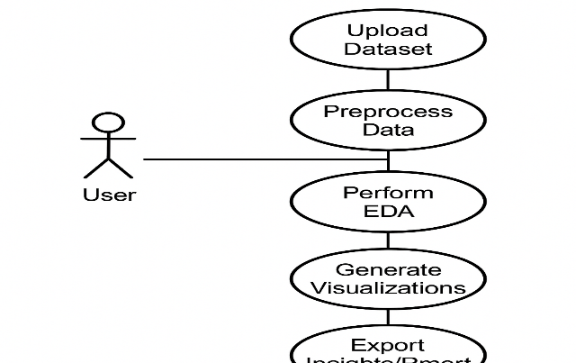
4.5.1 Use Case Diagram Description
Actor: User (Data Analyst)

Use Cases:
• Upload dataset
• Preprocess data
• Perform EDA
• Generate visualizations
• Export insights/report

4.5.2 Activity Diagram Description
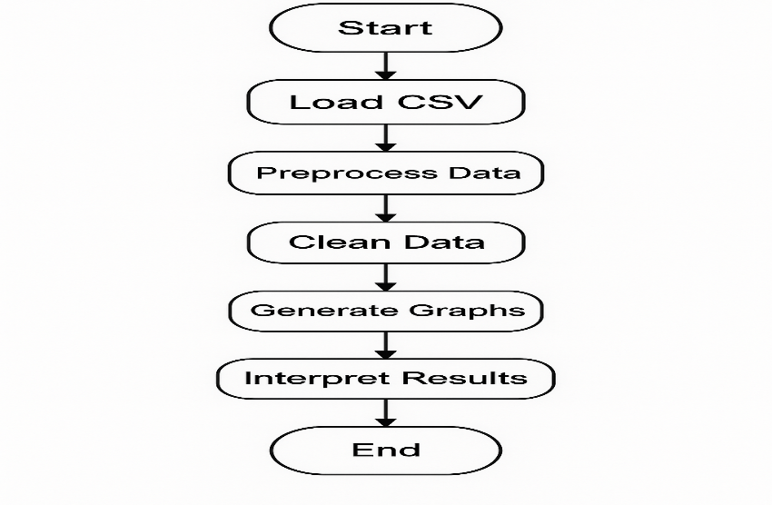
Start → Load CSV → Preprocess Data → Clean Data → Apply EDA → Generate Graphs → Interpret Results → End

4.5.3 Class Diagram Description
Classes:

Dataset
- attributes: rows, columns
- methods: load(), clean(), describe()

Analysis
- attributes: summary_stats
- methods: preprocess(), compute_discount(), visualize()

Visualization
- methods: plot_category(), plot_brand(), plot_price_distribution()

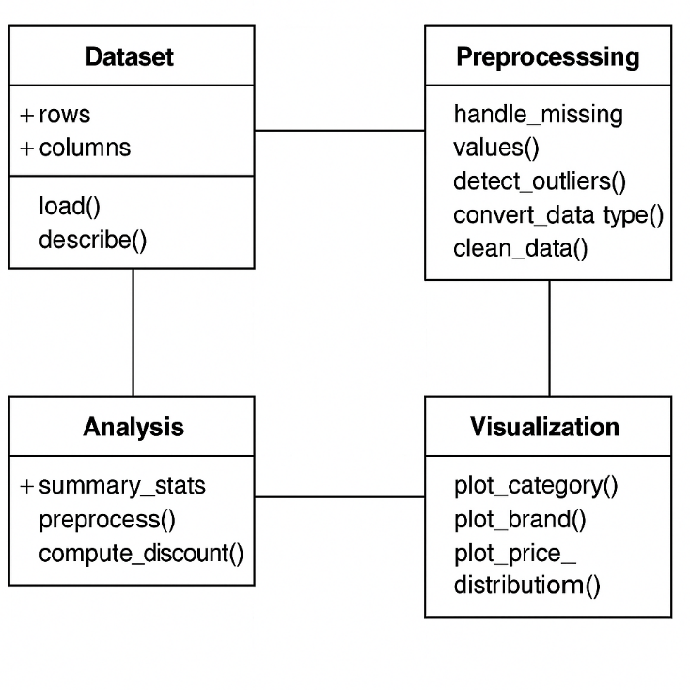

5. Project Plan
This chapter outlines the overall planning, time estimation, resource allocation, risk assessment, and scheduling required for the execution of the project “BigBasket Product & Pricing Analytics: An Advanced EDA Approach Using Real-World E-commerce Data.”

5.1 Project Estimate
The project estimation is done based on key phases of the data analysis lifecycle:
Activity | Estimated Time
Dataset Understanding | 2 days
Data Cleaning & Preprocessing | 4 days
Exploratory Data Analysis (EDA) | 4 days
Visualization Development | 3 days
Insight Interpretation | 2 days
Report Preparation | 5 days
Final Review & Submission | 2 days

Total Estimated Duration: 22 Days

5.1.1 Reconciled Estimates

After evaluating the workload and aligning with academic deadlines, the reconciled estimates are:
Task | Initial Estimate | Final Estimate
Preprocessing | 4 days | 3 days
Visualization | 3 days | 3 days
EDA | 4 days | 5 days
Report Writing | 5 days | 6 days
Final Agreed Duration: 23 Days

5.1.2 Project Resources

Software Resources
- Python 3.8+
- Google Colab / Jupyter Notebook
- Libraries: NumPy, Pandas, Matplotlib, Seaborn, Plotly
- MS Word for report building
Hardware Resources
- Laptop with minimum 4GB RAM (8GB recommended)
- Stable internet connection

5.2 Risk Management

Risk management ensures early identification and mitigation of challenges that may impact the project.

5.2.1 Risk Identification

Risk | Description
R1 | Dataset may contain inconsistencies or missing values
R2 | High number of outliers may distort visualizations
R3 | Python libraries may not be compatible or may fail to install
R4 | Time delay due to complex data cleaning
R5 | Notebook runtime issues (Google Colab session timeout)

5.2.2 Risk Analysis
Risk ID | Impact | Probability | Risk Level
R1 | Medium | High | High
R2 | Medium | Medium | Medium
R3 | Low | Medium | Low
R4 | High | Medium | High
R5 | Medium | Medium | Medium

5.2.3 Overview of Risk Mitigation, Monitoring & Management
Risk | Mitigation Strategy
R1 | Handle missing values using Pandas (mean/mode imputation)
R2 | Use IQR-based outlier treatment
R3 | Pre-install required libraries & keep backup environment
R4 | Use modular preprocessing functions to save time
R5 | Save progress frequently & use local Jupyter as fallback

5.3 Project Schedule
Timeline (Gantt-style textual schedule)

Week | Activities
Week 1 | Dataset understanding & data loading
Week 2 | Data cleaning & preprocessing
Week 3 | Exploratory Data Analysis (EDA)
Week 4 | Data visualization creation
Week 5 | Insight interpretation & report writing
Week 6 | Project review, diagrams & final submission

5.3.1 Project Task Set

Task 1: Collect BigBasket dataset
Task 2: Load data into Python environment
Task 3: Clean dataset (missing values, outliers)
Task 4: Preprocess numerical & categorical features
Task 5: Conduct statistical analysis
Task 6: Generate visualizations
Task 7: Interpret business insights
Task 8: Prepare report and diagrams
Task 9: Review & finalize project

6. PROJECT IMPLEMENTATION

6.1 Overview of Project Modules
This project is divided into structured modules to simplify the Exploratory Data Analysis (EDA) process on the BigBasket dataset:
Module 1: Dataset Loading
- Import required Python libraries
- Mount Google Drive
- Load the “BigBasket Products.csv” file
- Display initial records (head)
- Check dataset structure (shape, info, describe)
Module 2: Data Cleaning & Preprocessing
- Handling missing values using mean/mode imputation
- Replacing blank text fields with placeholder values
- Creating a new “discount” feature
- Checking and treating outliers using boxplots
- Ensuring consistent data types
Module 3: Exploratory Data Analysis (EDA)
- Category distribution
- Brand performance
- Price comparison across subcategories
- Rating visualization
- Top/least appearing products
Module 4: Visualization
- Bar plots
- Line charts
- Boxplots
- Countplots
- Color-coded category graphs
Module 5: Result Interpretation
- Pricing patterns
- High-value categories
- Popular brands
- Consumer interest insights
- Discount behavior analysis

6.2 Tools and Technologies Used
- Programming Language
- Python 3.8+
- Libraries Used
- NumPy – Numerical operations
- Pandas – Data manipulation
- Seaborn – Statistical visualization
- Matplotlib – Graph plotting
- Plotly Express – Interactive charts
- Development Environment
- Google Colab (Primary)
- Jupyter Notebook (Optional)
- Dataset Format
- CSV file containing 27,000+ BigBasket product entries

6.3 Algorithm Details

6.3.1 Algorithm: Missing Value Handling

Step 1: Identify columns with null values
Step 2: Fill numeric column nulls using mean()
Step 3: Fill categorical/text column nulls using mode()/custom strings
Step 4: Re-check missing values
Applied as:
rating → mean
discount → mean
sale_price → mean
product → “unknown”
brand → “unknown”
description → “not_present”

6.3.2 Algorithm: Discount Calculation
discount = (market_price - sale_price) / 100
Used to understand pricing strategy & offers.

6.4 Project Implementation (Final Code)

Below is the final clean and professional code used in the project.
# Mounting Google Drive to access files
from google.colab import drive
drive.mount('/content/drive')

# Importing Libraries for Data Manipulation and Visualization
import numpy as np
import pandas as pd
import seaborn as sns
import matplotlib.pyplot as plt
import plotly.express as px

# Reading the CSV file into a DataFrame named 'df'
df = pd.read_csv("/content/drive/MyDrive/bigbasket/BigBasket Products.csv")
print(df.head(12))
df.describe()
df.info()

# Creating the discount column
df["discount"] = df["market_price"] - df["sale_price"]
df["discount"] = df["discount"] / 100

# Checking missing values

df.isnull().sum()

# Outlier check for rating
sns.boxplot(df["rating"])
plt.show()

# Filling missing values
df["rating"].fillna(df["rating"].mean(), inplace=True)
df["discount"].fillna(df["discount"].mean(), inplace=True)
df["product"].fillna("unknown", inplace=True)
df["description"].fillna("not_present", inplace=True)
df["brand"].fillna("unknown", inplace=True)
df["sale_price"].fillna(df["sale_price"].mean(), inplace=True)

# Verifying cleaning
print("After cleaning missing values:")
df.isnull().sum()

# Frequency of products
df["product"].value_counts().sort_values(ascending=False).head()
df["product"].value_counts().sort_values(ascending=True).head()

# Visualize the Top 5 products
df["product"].value_counts().sort_values(ascending=False).head().plot(kind="bar")
plt.title("Top (5) product sold")
plt.xlabel("Products")
plt.ylabel("Count")
plt.show()

# Top seven sub_category by market price
plt.figure(figsize=(13, 5))
df.groupby("sub_category")["market_price"].sum().sort_values(ascending=False).head(7).plot(kind="bar", color="green")
plt.title("Total Market Price by Sub_category top(7)")
plt.xlabel("sub_category")
plt.ylabel("Total Market Price")
plt.grid(True)
plt.show()

# Top seven sub_category by Sale price
plt.figure(figsize=(13, 5))
df.groupby("sub_category")["sale_price"].sum().sort_values(ascending=False).head(7).plot(kind="bar", color="hotpink")
plt.title("Total sale Price by Sub_category top(7)")
plt.xlabel("sub_category")
plt.ylabel("Total Sale Price")
plt.grid(True)
plt.show()

# Total market price by category
plt.figure(figsize=(13, 5))
df.groupby("category")["market_price"].sum().plot(kind="line")
plt.title("Total Market Price by Category")
plt.xlabel("Category")
plt.ylabel("Total Market Price")
plt.grid(True)
plt.show()

# Top seven brand by market price
plt.figure(figsize=(13, 5))
df.groupby("brand")["market_price"].sum().sort_values(ascending=False).head(7).plot(kind="bar", color="#4CAF50")
plt.title("Total Market Price by Brand top(7)")
plt.xlabel("brand")
plt.ylabel("Total Market Price")
plt.grid(True)
plt.show()

# Count of category
sns.countplot(y=df["category"])
plt.title("Count of Category")
plt.xlabel("count")
plt.ylabel("category")
plt.show()

# Category by discount (mean)
df.groupby(["category"])["discount"].mean().plot(kind="bar")
plt.title("Average Discount by Category")
plt.xlabel("category")
plt.ylabel("Average Discount")
plt.show()

7. RESULTS

7.1 Mounting Google Drive to Access Files
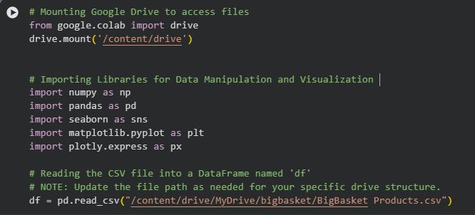

Figure 7.1: Mounting Google Drive using drive.mount()
Explanation:
Google Drive was mounted to access the BigBasket dataset directly from cloud storage.
Ye ensures dataset path always accessible rahe.

7.2 Importing Required Python Libraries


Figure 7.2: Import statements of NumPy, Pandas, Seaborn, Matplotlib, Plotly
Explanation:
Essential libraries were imported for:
- Data manipulation (Pandas, NumPy)
- Statistical graphics (Seaborn)
- Visual plots (Matplotlib)
- Interactive visuals (Plotly Express)

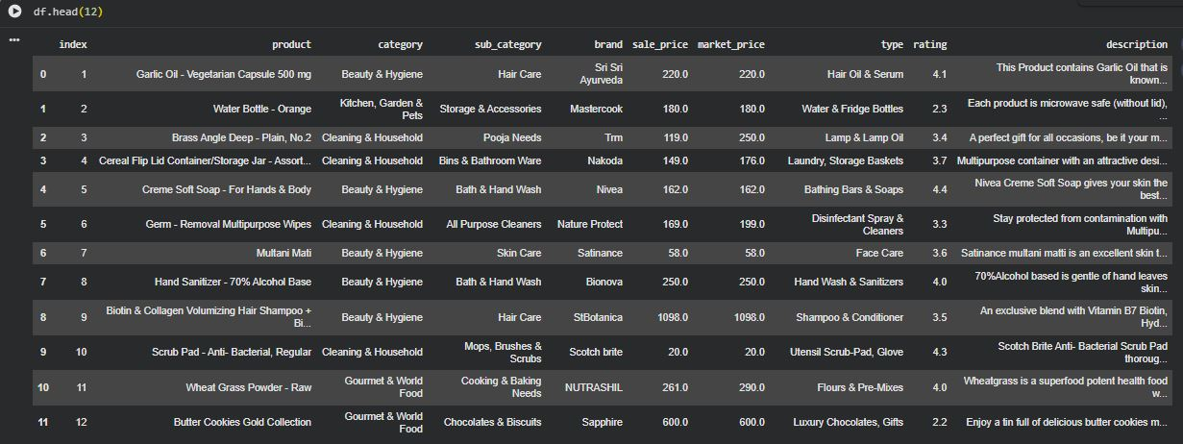
7.3 Reading Dataset into DataFrame (df)
Figure 7.3: Screenshot of df.head(12)
Explanation:
The first 12 rows show columns like product, category, brand, sale price, market price, rating and description.
Insight: Dataset is cleanly structured and ready for preprocessing & analysis.

7.4 Statistical Summary (df.describe())
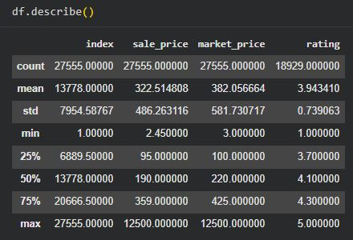

Figure 7.4: Statistical summary output
Key points:
- Average sale price → ₹322.52
- Average market price → ₹382.6
- Rating average → 3.94
- Max market price → 12,500
Insight:
Prices have large variation → outlier analysis required.

7.5 Dataset Information (df.info())
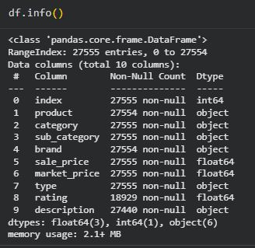

Figure 7.5: df.info() output
Observation:
- 27,555 entries
- Missing values in product, brand, rating, description, sale_price
Insight:
Cleaning is mandatory for reliable visualizations.

7.6 Creating Discount Column
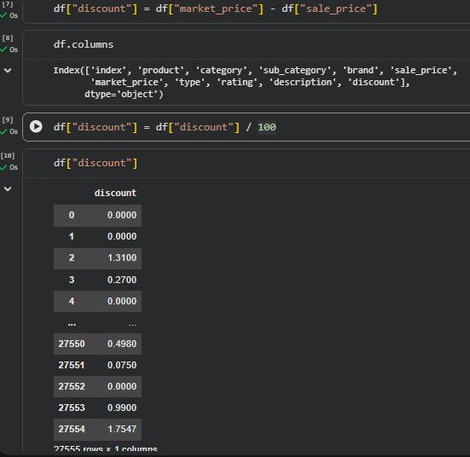

Figure 7.6: Discount creation code
Formula:
discount = market_price – sale_price
Insight:
Helps evaluate offers and pricing strategy.

7.7 Checking Missing Values (BEFORE Cleaning)
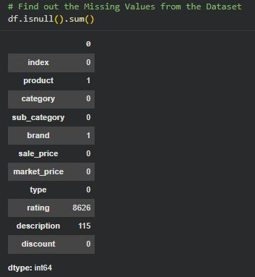

Figure 7.7: df.isnull().sum() before cleaning
Missing Values:
- rating → 8626
- description → 115
- product → 1
- brand → 1
- sale_price → 6
Insight:Rating column has most missing values → imputation needed.

7.8 Preview of Discount Column
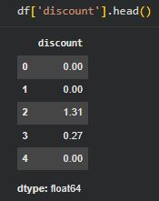

Figure 7.8: df['discount'].head()

Insight:Discount looks properly calculated and numeric.

7.9 Outlier Detection – Rating Boxplot
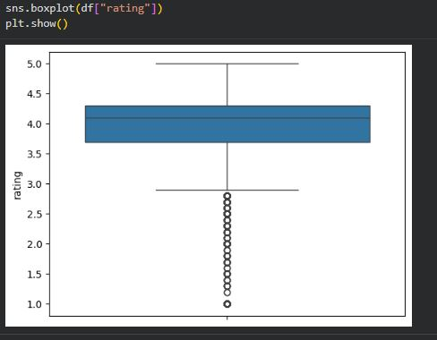

Figure 7.9: Boxplot of rating

Observation:
- Majority ratings between 3–5
- Many outliers near 1 rating
Insight:
Either poor-rated products or missing rating behavior.

7.10 Filling Missing Values (Cleaning Code)
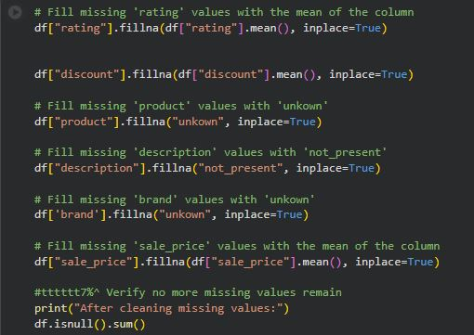

Figure 7.10: Cleaning code screenshot
Actions performed:
- rating → mean
- discount → mean
- product → “unknown”
- brand → “unknown”
- description → “not_present”
- sale_price → mean
Insight:
After cleaning, dataset becomes fully usable.

7.11 Missing Values AFTER Cleaning
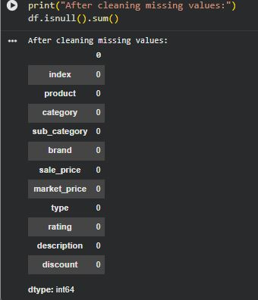

Figure 7.11: df.isnull().sum() after cleaning
Observation:
All missing values → 0
Insight:
Dataset is now completely cleaned and ready for EDA.

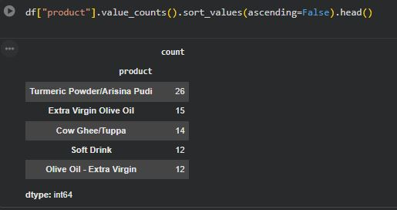
7.12 Frequency of Products (Top & Bottom)

Figure 7.12: Top 5 frequent products
Observation:
- Turmeric Powder/Arisina Pudi appears most (26 times).
Business Insight:
High catalog presence indicates strong demand or multiple variants.
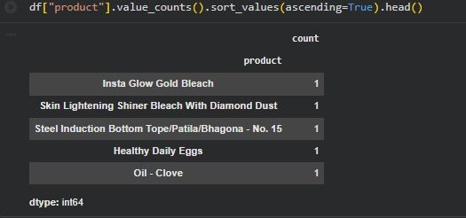

Figure 7.13: Bottom 5 products
Insight:
These products appear only once → low coverage items.

7.13 Visualizing Top 5 Products Sold
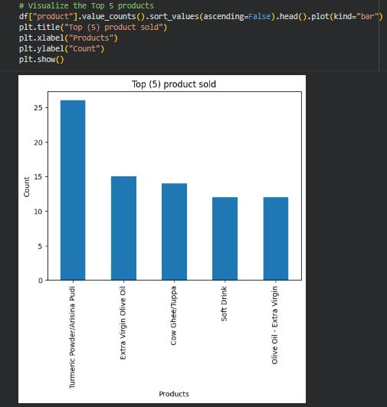

Figure 7.14: Bar graph of top 5 products
Insight:Frequently listed items → high demand categories.

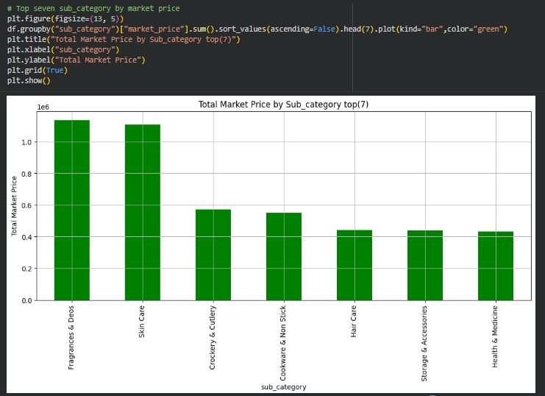
7.14 Top 7 Sub-Categories by Market Price
Figure 7.15: Market price by sub-category
Top categories:
- Fragrances & Deos
- Skin Care
- Crockery & Cutlery
Insight:
Premium categories contribute major share of listing value.

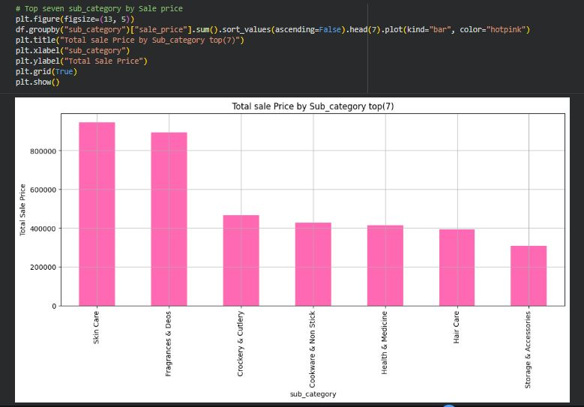
7.15 Top 7 Sub-Categories by Sale Price
Figure 7.16: Sale price graph
Observation: Skin Care and Fragrances show highest sale value.

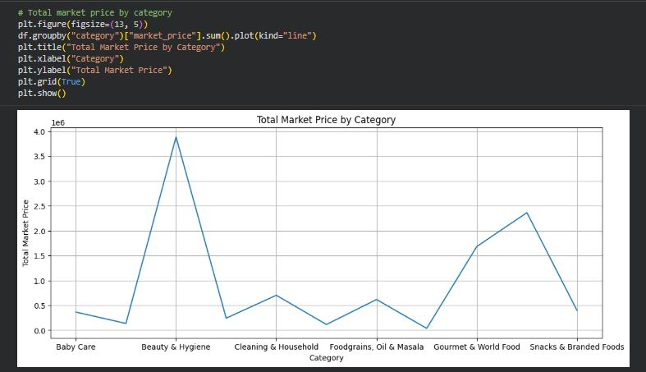
7.16 Total Market Price by Category
Figure 7.17: Line plot category-wise
Insight:
- Beauty & Hygiene dominates by a large margin
- Some categories have very low value → niche items

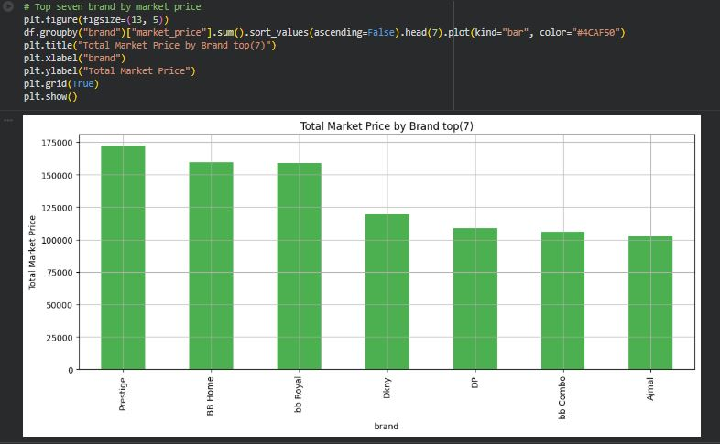
7.17 Top 7 Brands by Market Price
Figure 7.18: Brand bar chart
Insight:Prestige, BB Home, BB Royal lead product value.

7.18 Count of Category
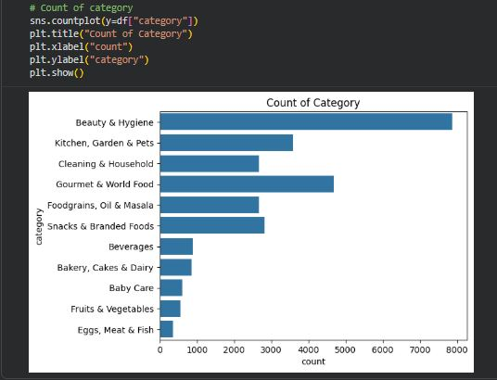

Figure 7.19: Category-wise count
Insight:
Beauty & Hygiene largest category (8000+ products).

7.19 Average Discount by Category
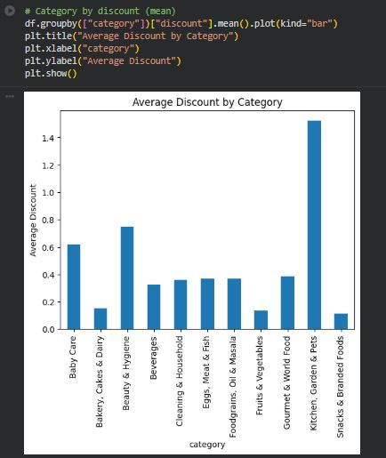

Figure 7.20: Discount bar chart
Key Insight:Kitchen, Garden & Pets has highest avg discount → promotional attractor.

8.CONCLUSION

8.1 Conclusion
This project involved a complete Exploratory Data Analysis (EDA) of the BigBasket Product Dataset containing 27,555 product entries across multiple categories, sub-categories, brands, and price levels.
By performing data cleaning, preprocessing, and visualization, several meaningful insights were discovered.
Key Conclusions:
1. Dataset Quality Improved Significantly
- Large number of missing values (especially in rating) were identified and handled effectively.
- After cleaning, dataset became 100% complete (no missing values).
2. Strong Category-Level Patterns Found
- Beauty & Hygiene emerged as the category with the highest number of listed products and highest market value.
- Skin Care and Fragrances & Deos dominated both sale price and market price segments.
3. Product Demand Indicators
- Items like Turmeric Powder, Olive Oil, and Cow Ghee appeared most frequently, indicating high consumer interest and multiple product variants.
4. Brand Performance
- Prestige, BB Home, and BB Royal showed the highest total market value among brands.
5. Discount Trends
- The Kitchen, Garden & Pets category offered the highest average discount, indicating strong promotional strategies in this segment.
6. Price Variation and Outliers
- Significant price differences across categories indicated presence of premium as well as budget product segments.
- Rating outliers showed variation in customer satisfaction.

8.2 Future Scope
Although the EDA provided strong insights, the project can be extended further using advanced techniques:
1. Machine Learning-Based Price Prediction
A regression model can be built to predict sale price based on:
- brand
- category
- rating
- discount
- description keywords
2. Sentiment Analysis on Product Descriptions
Using NLP models, the product description text can be used to understand customer perception and product positioning.
3. Customer Review-Based Insights
If customer reviews data becomes available, it can generate:
- satisfaction levels
- sentiment polarity
- feature-based ratings

4. Dashboard Development
A fully interactive dashboard using:
- Tableau
- Power BI
- Plotly Dash
can help visualize real-time product trends.
5. Deep Learning for Product Categorization
Product description + image (if available) can be used to auto-classify products using CNN + LSTM models.

8.3 Applications
This project has strong industrial and academic applications:
1. E-Commerce Platforms (BigBasket, Amazon, Flipkart)
- Can understand which categories perform best
- Identify which brands require promotion
- Optimize pricing strategy based on demand and discounts
2. Retail Management
- Helps businesses plan inventory
- Stock high-demand products
- Track seasonal price changes
3. Digital Marketing
- High-discount categories can be promoted in ads
- Popular brands & products can be highlighted
4. Consumer Behavior Research
- Identify customer preferences based on category values
- Analyze the impact of pricing and discount strategy on consumer choices
5. Academic Learning
- Helps students understand real-life EDA workflow
- Provides strong foundation for machine learning and data science concepts

8.4 Final Summary
This project successfully demonstrates how data cleaning, EDA, and visualization can reveal important trends in a real-world e-commerce dataset.
The insights generated can help improve business decisions, pricing strategies, product placement, and customer satisfaction.

REFERENCES

[1] BigBasket Dataset, “BigBasket product dataset – public version,” Kaggle, 2024. [Online]. Available: https://www.kaggle.com

[2] Pandas Documentation, “Python data analysis library,” 2024. [Online]. Available: https://pandas.pydata.org

[3] NumPy Documentation, “Scientific computing tools for Python,” 2024. [Online]. Available: https://numpy.org

[4] Matplotlib Developers, “Matplotlib plotting library,” 2024. [Online]. Available: https://matplotlib.org

[5] Seaborn Documentation, “Statistical data visualization,” 2024. [Online]. Available: https://seaborn.pydata.org

[6] Plotly Express Documentation, “Interactive data visualization tools,” 2024. [Online]. Available: https://plotly.com/python

[7] Google Colaboratory, “Colab: A cloud-based Python notebook environment,” 2024. [Online]. Available: https://colab.research.google.com

